E COMMERCE DATA ANALYSIS

1. Project Title
E-Commerce Sales and Customer Analysis Using SQL and Excel

2. Introduction
Name: Swathi P
Department: BSC Computer Science with AI Intel
Register No: RCAS2024BCS134
Branch: R-SMART PRO

Project Introduction:
The rapid growth of e-commerce platforms has generated large volumes of transactional and customer data. Analyzing this data helps organizations understand customer behavior, sales performance, and business trends. This project focuses on analyzing an e-commerce sales dataset using SQL for data querying and Microsoft Excel for data cleaning, analysis, visualization, and dashboard creation. The analysis provides meaningful business insights that support data-driven decision-making.

3. Objectives
The main objectives of this project are:
- To design a structured database for e-commerce sales data
- To use SQL queries for data retrieval, filtering, aggregation, and analysis
- To clean and process data using Excel functions
- To analyse sales trends, customer performance, and product contribution
- To build an interactive Excel dashboard for business insights

4. Dataset Description
The dataset used in this project is a Superstore Sales dataset. It contains transactional-level sales data with the following key attributes:
- Order Details: Order ID, Order Date, Ship Date, Ship Mode
- Customer Details: Customer ID, Customer Name, Segment, Country, Region
- Product Details: Product ID, Category, Sub-Category, Product Name
- Sales Information: Sales value
The dataset represents multiple years of sales transactions and is suitable for time-based, customer-based, and product-based analysis.

5. Tools Used
- MySQL for Database creation, constraints, joins, subqueries, and aggregation
- Microsoft Excel for Data cleaning, formulas, pivot tables, charts, and dashboard creation

6. Database Design
A primary Sales table was designed to store transactional data. Key design considerations include:
- Primary Key: Row ID / Order ID to uniquely identify records
- NOT NULL Constraints: Applied to Order ID, Order Date, Customer ID, and Sales to ensure data integrity
- CHECK Constraints: Used on Sales and Quantity columns to prevent negative or invalid values
Proper constraints help maintain data accuracy and consistency during analysis.

7. SQL Implementation
SQL was used to analyze the dataset through structured queries:
- Aggregate functions such as SUM, AVG, COUNT to calculate total revenue, average order value, and customer orders
- GROUP BY and HAVING clauses to identify high-performing countries and customers
- ORDER BY to rank products and transactions based on sales
- Date functions to extract year and month and compute monthly and yearly sales trends
- Subqueries to compare individual customer performance against averages
- JOINS to combine sales and customer details and identify unmatched records.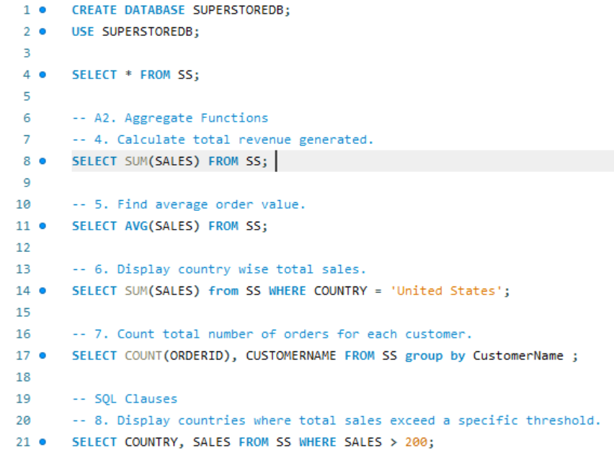
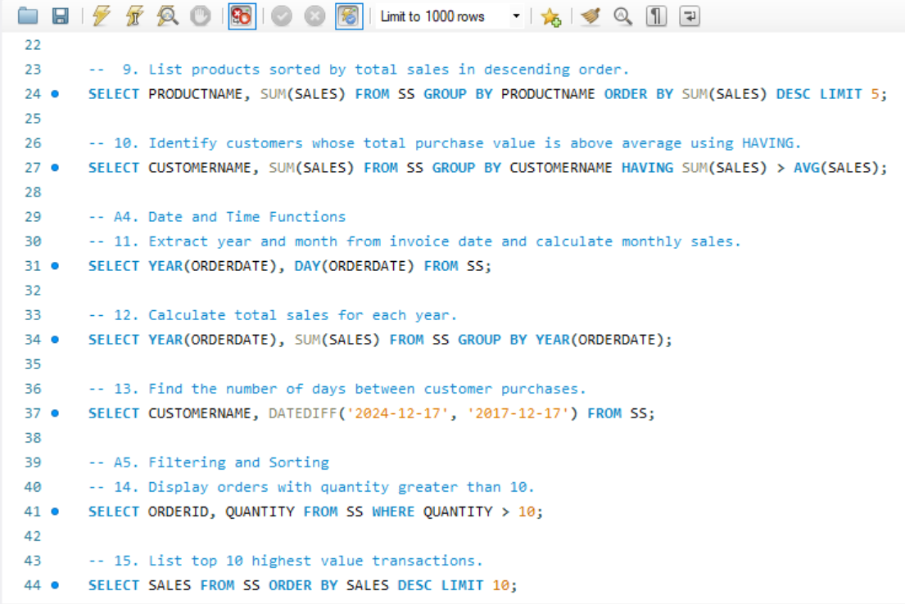

8. Excel Implementation
Excel was used extensively for data preparation and analysis:
- Lookup functions (VLOOKUP/XLOOKUP): To fetch customer country and product descriptions
- Data cleaning: Removing duplicates, trimming extra spaces, and handling missing values
- Conditional formatting: Highlighting high-value transactions and invalid quantities
- Data validation: Dropdown lists for country and restrictions on quantity values
- Pivot tables and charts: For country-wise sales, monthly sales trends, and product performance
Excel enhanced data visualization and supported interactive analysis.

9. Data Analysis
Key findings from the data analysis include:
- Total Sales: Approximately 2.26 million in total revenue
- Top Country by Revenue: United States generated the highest sales
- Top Product Sub-Categories: Phones, Chairs, and Storage contributed the most to total sales
- Top Customers: A small group of customers contributed significantly to overall revenue
- Seasonal Trends: Sales were relatively lower during early months (January–February) in some years, indicating seasonal variation
- Bulk Purchases: Higher quantities per order resulted in higher revenue, showing a positive impact of bulk buying

10. Dashboard and Insights
An interactive Excel dashboard was created with the following components:
- KPIs showing Total Sales, Total Customers, and Total Orders
- Pivot charts displaying monthly and yearly sales trends
- Slicers for Country and Product Category to enable dynamic filtering
- Timeline control for time-based analysis
The dashboard allows users to quickly identify top-performing regions, products, and customers.

My Excel Dashboard:
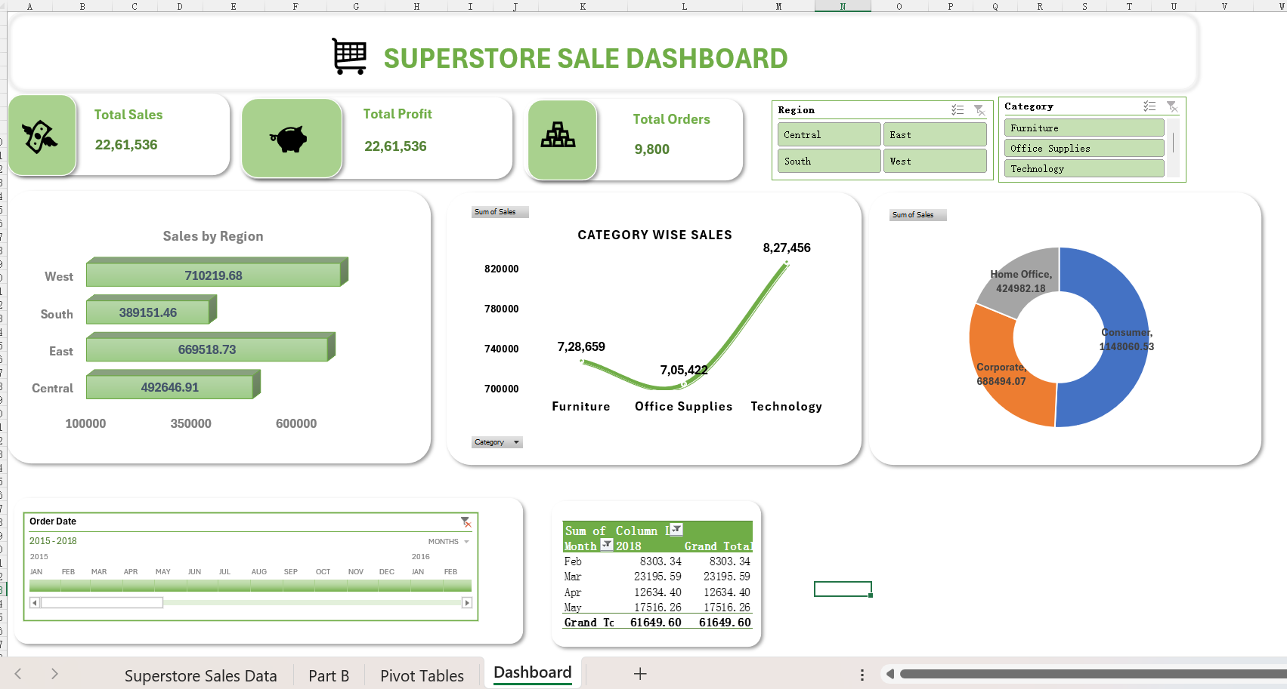

Pivot Tables I Used:
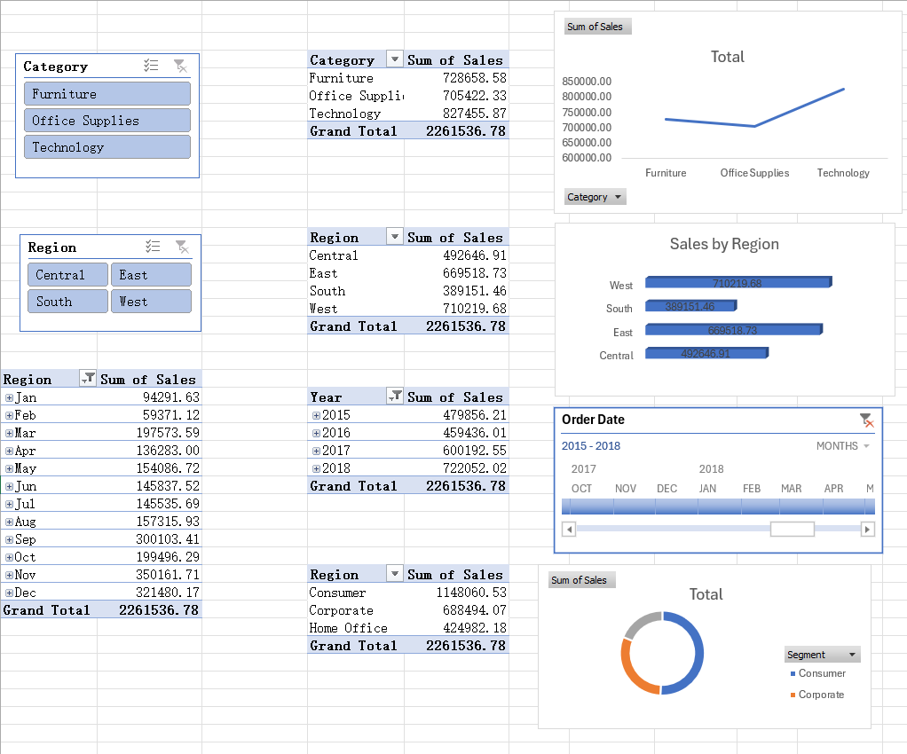
11. Conclusion
This project successfully demonstrates how SQL and Excel can be combined for end-to-end data analysis. SQL enabled efficient querying and aggregation of large datasets, while Excel supported data cleaning, visualization, and dashboard creation. The analysis provided clear insights into sales performance, customer contribution, and product trends, supporting informed business decisions.

12. Future Scope
Future enhancements to this project may include:
- Integrating profit and discount data for deeper financial analysis
- Automating data updates using Power Query or ETL tools
- Using advanced SQL features such as stored procedures and views
- Applying predictive analytics to forecast future sales trends
- Migrating dashboards to BI tools such as Power BI or Tableau

